Steele Memorial United Methodist Church
733 Shaw Street, PO Box 346
Barboursville, WV 25504
October 27, 2013

Anyone who tries to justify themselves only before others must remember that God knows their heart. (Luke 16:15)

THE PRELUDE
Please sign the Pew Pad and pass it to the person next to you. Please include your full address, phone number, and email address if you are new to this congregation or a visitor.

THE WELCOME AND ANNOUNCEMENTS
This is a time to share the work of the church and recognize the community of believers as we prepare our hearts and minds to worship the Lord.

**THE HYMN “Amazing Grace” No. 378

THE CHILDREN’S TIME

THE PRAYERS OF CONFESSON, ASSURANCE AND PARDON No. 891

THE CONCERNS AND THANKSGIVINGS

THE LORD’S PRAYER

**THE PRESENTATION OF OUR TITHES AND OFFERINGS
OFFERING:
We’ve come to that time in the service when we collect the financial offerings and tithes. Your financial commitment sustains our many vital ministries. May God bless you, the giver, and your gift in the up-building of God’s kingdom.

**“Praise God”
“Praise God, from whom all blessings flow; praise him, all creatures here below; praise him above, ye heavenly host; praise Father, Son, and Holy Ghost. Amen”

Children ages 4 through 1st grade may exit for Children’s Church and go downstairs to the 4th grade All Stars classroom. Children in 2nd through 5th grade may go to Junior Church downstairs in the 5th grade All Stars classroom. Both rooms are located by the New Fellowship Hall. Children, birth to age 3, are welcome to go to the nursery on the first floor.

**THE HYMN “Pass Me Not, O Gentle Saviour” No. 351

THE ANTHEM “He Leadeth Me” Chancel Choir

THE TEXT Luke 18:9-14 (RSV)
THE SERMON “Which Comes First?” Rev. Dr. John Sauvage
Our Actions or Our Attitude

**THE INVITATION “Just As I Am, Without One Plea” No. 357

THE BENEDICTION “Turn Your Eyes upon Jesus” No. 349

Carry Forth the Light of Christ: May each of us carry the light of Christ wherever we find ourselves in this world.

THE POSTLUDE

PERSONNEL AND STAFF OF STEELE MEMORIAL

Pastor Rev. Dr. John Sauvage Associate Pastor Rev. Ralph G. Sager
Youth Director Nathan Davenport Music Director Johnna Adkins
Pianist Lynette Call Organist Becky Chenoweth
Lay Leader John Call Treasurer Cheryl Sullivan
Secretary Jonnie Johnson Custodian Fern Allred

WEEKLY OPPORTUNITIES AND RESPONSIBILITIES

Sunday, October 27  9:00 Early Worship Service  9:45 Sunday School For All Ages  11:00 Morning Worship Service  Finance Committee Meeting after  Morning Worship Service  6:00 Youth  6:30 Evening Worship  Monday, October 28  6:30 Cub Scouts and Sea Scouts  7:30 Boy Scouts  Tuesday, October 29  7:00 Beth Moore Bible Study | Wednesday, October 30  5:30 All Stars  5:30 Middle School All Stars  6:30 All Stars Trunk or Treat  6:45 Bible Study  6:45 Youth-Costume Party  7:45 Choir Practice  Thursday, October 31  6:00 Troop 88  Sunday, November 3  All Saints Sunday  Daylight Saving Time Ends  9:00 Early Worship Service  9:45 Sunday School For All Ages  11:00 Morning Worship Service  6:00 Youth  6:30 Evening Worship

October 20, 2013
GENERAL FUND STEWARDSHIP REPORT

Year to Date Weekly Offering
Amount Needed: $380,836.46 Amount Needed: $9,123.55
Amount Received: $357,623.99 Amount Received: $5,396.02
Tree of Life to Date: $6,735.00
Shortfall: $23,212.47

LAST SUNDAY ATTENDANCE
Sunday school: 137 Early Worship Service: 38
Morning Worship Service: 148 Evening Worship Service: 32 STEELE MEMORIAL
UNITED METHODIST CHURCH

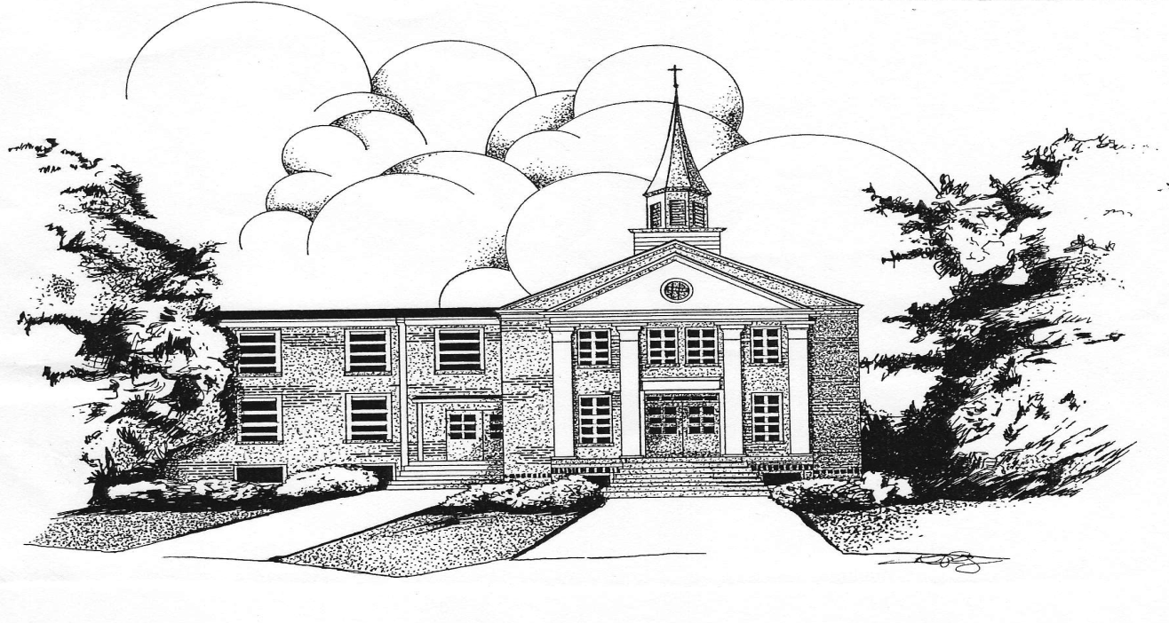

733 Shaw Street - PO Box 346
Barboursville, West Virginia
Office Phone: (304)736-4583
E-mail Address: steelememorialumc@frontier.com

The purpose of Steele Memorial United Methodist Church is to enable people to know Jesus Christ as Savior and Lord; to nurture them in their journey of faith; to offer opportunities to express their relationship with the living God through love, example, and service.

