Steele Memorial United Methodist Church
733 Shaw Street, PO Box 346
Barboursville, WV 25504
October 20, 2013
Laity Sunday

But ye shall receive power, after that the Holy Ghost is come upon you: and ye shall be witnesses unto me both in Jerusalem, and in all Judaea, and in Samaria, and unto the uttermost part of the earth. (Acts 1:8)

THE PRELUDE
Please sign the Pew Pad and pass it to the person next to you. Please include your full address, phone number, and email address if you are new to this congregation or a visitor.

THE WELCOME AND ANNOUNCEMENTS Jack Perkins
This is a time to share the work of the church and recognize the community of believers as we prepare our hearts and minds to worship the Lord.

**THE HYMN “Rescue the Perishing” No. 591

THE CHILDREN’S TIME Brenda Chapman

THE CONCERNS AND THANKSGIVINGS Jack Perkins

THE LORD’S PRAYER

**THE PRESENTATION OF OUR TITHES AND OFFERINGS

THE DUET Nate and Suzanna Davenport
OFFERING:
We’ve come to that time in the service when we collect the financial offerings and tithes. Your financial commitment sustains our many vital ministries. May God bless you, the giver, and your gift in the up-building of God’s kingdom.

**“Praise God”
“Praise God, from whom all blessings flow; praise him, all creatures here below; praise him above, ye heavenly host; praise Father, Son, and Holy Ghost. Amen”

Children ages 4 through 1st grade may exit for Children’s Church and go downstairs to the youth room beside the kitchen. Children in 2nd through 5th grade may go to Junior Church downstairs in the 4th and 5th grade Sunday school class. Children, birth to age 3, are welcome to go to the nursery on the first floor.

**THE HYMN “Onward Christian Soldiers” No. 575 (vs 1, 3, 5)

THE ANTHEM “No, Not One” Chancel Choir

THE TEXT Acts 6:1-7; 13:36 Richard Fillmore

THE SERMON “What Can a Layperson Do?” John Call

**THE INVITATION “I Surrender All” No. 354

THE BENEDICTION “Turn Your Eyes upon Jesus” No. 349

Carry Forth the Light of Christ: May each of us carry the light of Christ wherever we find ourselves in this world.

THOUGHT FOR THE DAY
Live as though Christ died yesterday, rose this morning, and is coming back before tomorrow.

THE POSTLUDE

PERSONNEL AND STAFF OF STEELE MEMORIAL

Pastor Rev. Dr. John Sauvage Associate Pastor Rev. Ralph G. Sager
Youth Director Nathan Davenport Music Director Johnna Adkins
Pianist Lynette Call Organist Becky Chenoweth
Lay Leader John Call Treasurer Cheryl Sullivan
Secretary Jonnie Johnson Custodian Fern Allred

WEEKLY OPPORTUNITIES AND RESPONSIBILITIES

Sunday, October 20  Laity Sunday  Youth are Ushering  9:00 Early Worship Service  9:45 Sunday School For All Ages  11:00 Morning Worship Service  6:00 Youth  6:30 Evening Worship  Monday, October 21  6:30 Cub Scouts and Sea Scouts  7:00 Christian Education Committee  Meeting  7:30 Boy Scouts  Tuesday, October 22  7:00 Beth Moore Bible Study | Wednesday, October 23  5:30 All Stars  5:30 Middle School All Stars  6:45 Bible Study  6:45 Youth  7:45 Choir Practice  Thursday, October 24  6:00 Troop 88  Sunday, October 27  9:00 Early Worship Service  9:45 Sunday School For All Ages  11:00 Morning Worship Service  6:00 Youth  6:30 Evening Worship

October 13, 2013
GENERAL FUND STEWARDSHIP REPORT

Year to Date Weekly Offering
Amount Needed: $371,712.90 Amount Needed: $9,123.55
Amount Received: $352,227.97 Amount Received: $9,998.52
Tree of Life to Date: $6,635.00
Shortfall: $19,484.93

LAST SUNDAY ATTENDANCE
Sunday school: 153 Early Worship Service: 41
Morning Worship Service: 228
STEELE MEMORIAL
UNITED METHODIST CHURCH

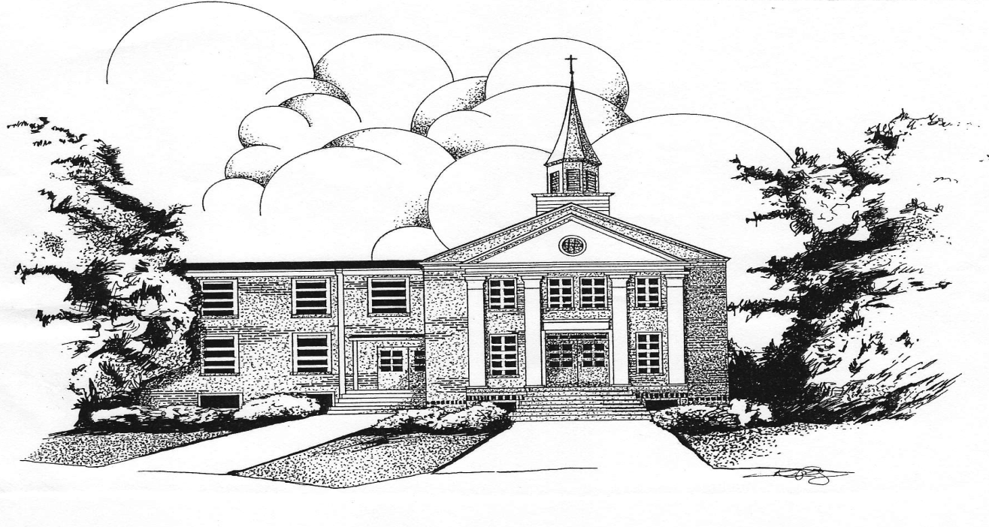

733 Shaw Street - PO Box 346
Barboursville, West Virginia
Office Phone: (304)736-4583
E-mail Address: steelememorialumc@frontier.com

The purpose of Steele Memorial United Methodist Church is to enable people to know Jesus Christ as Savior and Lord; to nurture them in their journey of faith; to offer opportunities to express their relationship with the living God through love, example, and service.

